**COMP 370 – Software Engineering**  
**Term Project**  
Problem 11.24

Question: (Term Project) Perform the requirements workflow for the Chocoholics Anonymous project in Appendix A.

The overview of the Requirements Workflow includes:

1. Gain an understanding of the application domain or domain.
2. Build a business model.
3. Use the business model to determine the client’s requirements.
4. Iterate the above steps.

The initial glossary for Chocoholics Anonymous:

|  |  |
| --- | --- |
| Business Terms | Descriptions |
| Accounts Payable | Amounts of money that ChocAn must pay to providers for services rendered to ChocAn members. |
| Accounting Procedure | Procedure that is run at midnight each Friday at the ChocAn Data Center. It produces the EFT data and various reports. |
| Accounting System | An information system to be developed by Acme Accounting Services. This system will be responsible for financial procedures such as recording payments of membership fees, suspending members whose fees are overdue, and reinstating suspended members who have now paid what is owed. |
| Addiction | An obsession, compulsion or excessive physical or psychological dependence on some substance such as chocolate. |
| Chocolate | A delicious food made from cacao beans. One of the most popular flavours of the world. |
| Chocoholics Anonymous. (ChocAn) | An organization dedicated to helping members overcome addiction to chocolate. |
| ChocAn Data Center | The building where the main computer (server) of ChocAn is housed. |
| ChocAn Manager | A member of the staff of ChocAn, in a management position, who requires information about the services provided to members during a particular week, as well as the fees to be paid to the providers. |
| ChocAn Operator | A member of the staff of ChocAn who has the role of maintaining the information about members and providers, i.e. adding a new member or provider, updating details and deleting a member or provider who resigns. |
| Claim | A request for money due to a provider for a service rendered. |
| Consultation | An occasion where a provider renders a service to a member of ChocAn. |
| Dietitian | A health-care professional who compiles a diet tailored for an individual, and monitors his or her progress. |
| Electronic Funds Transfer (EFT) | A transaction in which an amount of money is transferred from one bank account to another via the internet. |
| EFT data | Data to be used to transfer funds electronically from the ChocAn bank account to the providers’ bank account. |
| EFT Component | A component of the ChocAn Information System that will be implemented by a different organization. This component will ensure that each provider’s account is credited with the appropriate amount. |
| Exercise Specialist | A health-care professional who compiles an exercise routine tailored for an individual, and monitors his or her progress. |
| Internist | A health-care professional who is a medical practitioner specializing in the diagnosis, management and non-surgical treatment of illness. |
| Member | A person who is addicted to chocolate and has joined ChocAn to benefit from the services provided. |
| Member Number | A 9-digit number that uniquely identifies a ChocAn member. |
| Member Status | The status of a member may be Active (the member is up to date with payments and entitled to consultations) or Suspended (the member has not paid fees for at least a month and is not entitled to consultations). |
| Membership Card | A plastic card embossed with the member’s name and number, and incorporating a magnetic strip on which the same information is encoded. |
| Membership Fee | A monthly amount of money that a member must pay to ChocAn to be entitled to consultations with providers. |
| Provider | A health-care professional who provides services to ChocAn members. Before providing a service, the provider can verify that the member has a valid membership card, and is not suspended. After providing a service to a member, the provider bills ChocAn by submitting a claim. |
| Provider Directory | An alphabetically ordered list of service names and corresponding service codes and fees. |
| Provider Number | A 9-digit number that uniquely identifies a ChocAn provider. |
| Provider Terminal | A specifically designed computer terminal, similar to a credit card device in a shop, incorporating a card reader that can read the magnetic strip on a member’s card, a keyboard, and a one-line display. |
| Provider Type | The type of provider, namely dietician, internist or exercise specialist. |
| Scheduler | The mechanism that ensures that the accounting procedure is run at set times. The set times are currently midnight on Fridays. |
| Service | A classification of a treatment, consultation or session with a provider. Example, an aerobic exercise session, a clinical session with a Dietitian, or a consultation session with internist. |
| Service Code | A 6-digit code that uniquely identifies a service. |
| Treatment | A synonym for consultation. |

Part 1 of Chocoholics Anonymous use-case diagram shows the use cases that are part of the business model, but not part of the requirements model.

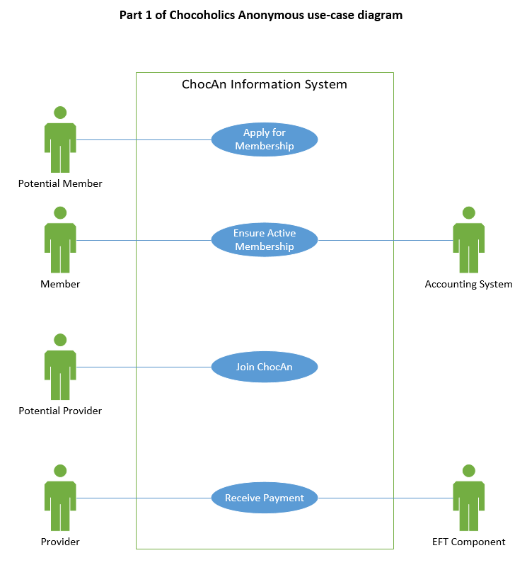

**Description of the Apply for Membership use case**

|  |
| --- |
| Brief Description: The Apply for membership use case enables a potential member to become a member of Chocoholics Anonymous. |
| Step-by-Step Description:   1. The potential member fills in an application form and submits it to Chocoholics Anonymous. 2. The staff member responsible for screening applicants decides, using ChocAn business rules whether the potential member should be accepted as a member. 3. The staff member informs the potential member of the decision, and if the potential member was accepted, the staff member requests him to pay the monthly fee for the first month. 4. The new member pays the fee for the first month. A ChocAn operator now uses the Maintain Member use case to record the new member’s details and allocate a member number to him.   A staff member prints a membership card for the new member and sends the card to him. The new member is now entitled to unlimited consultations and treatments with ChocAn providers. |

**Description of the Make Payment use case**

|  |
| --- |
| Brief Description: The Ensure Active Membership use case enables a member to continue to be an active member of Chocoholics Anonymous by paying the monthly fee. |
| Step-by-Step Description:   1. The member submits the payment of the monthly fee to Chocoholics Anonymous. 2. The staff member responsible for payments uses the Accounting System to record the payment and send a receipt to the member. 3. The Accounting System updates the member’s status to Active. |

**Description of the Join ChocAn use case**

|  |
| --- |
| Brief Description: The Join ChocAn use case enables a potential provider to join ChocAn. |
| Step-by-Step Description:   1. The potential provider submits all required information to ChocAn. 2. A staff member responsible for screening providers decides, using ChocAn business rules whether the provider should be accepted as a ChocAn approved provider. 3. The staff member informs the potential provider of the decision. A ChocAn operator now uses the Maintain Provider use case to record the new provider’s details and allocate a provider number to him. 4. A staff member supplies the provider with a provider terminal and his or her provider number. The new provider may now provide services for ChocAn members and bill ChocAn for those services. |

**Description of the Receive Payment use case**

|  |
| --- |
| Brief Description: The Receive Payment use case enables the provider to receive payment for services provided to ChocAn members. |
| Step-by-Step Description:  1. At the end of each week, the EFT component transfers the money claimed by a provider during that week into the provider’s account. |

Part 2 of Chocoholics Anonymous use-case diagram shows those use cases in which the provider is the primary system actor.

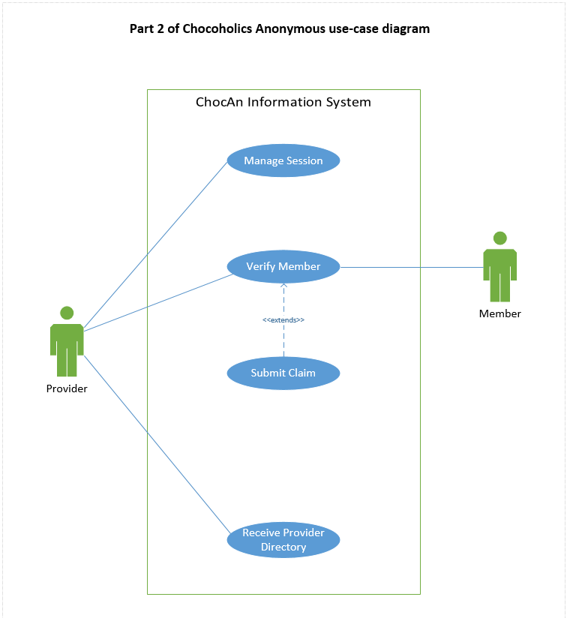

**Description of the Manage Session use case**

|  |
| --- |
| Brief Description: The Manage Session use case enables the provider to log on to the ChocAn system, use the various functions available to him and be able to log off again. |
| Step-by-Step Description:   1. When the provider switches his provider terminal on, the system prompts him to enter his provider number. 2. The provider supplies his provider number. 3. The system searches for this provider number. 4. The system displays the result of the search.   4a. If no such provider is found, the system displays an Invalid Number message.  4b. If the provider is found, the system displays the options available to the provider. The provider can now use the system as in use cases Verify Member and Receive Provider Directory.   1. When the provider chooses the Quit option or switches the terminal off, the system ends the session. |

**Description of the Verify Member use case**

|  |
| --- |
| Brief Description: The Verify Member use case enables a provider to verify that a member has a valid member number and that the member is not suspended. |
| Step-by-step Description:   1. The provider swipes the member’s card through the card reader of the provider terminal, or keys in the member number (when the claim is submitted at a later date or time). 2. The system searches for a member with this number. 3. The system displays the result of the verification.   3a. If no such member is found, the system displays an Invalid number message.  3b. If the member is found, the system displays a message indicating the status of the member e.g. Suspended if the member is suspended or Validated if the member is active. |

**Description of the Submit Claim use case**

|  |
| --- |
| Brief Description: The Submit Claim use case enables a provider to bill Chocoholics Anonymous for a service provided to a member. |
| Step-by-Step Description: After a provider has verified a member, the message Validated appears on the provider’s terminal and the provider can continue to submit a claim.   1. The provider enters the date the service was provided in the format MM-DD-YYYY and the service code. 2. The system verifies that the service code exists. If it does, the system displays the corresponding service name. 3. The provider confirms that this is the correct service rendered. 4. The system stores the following information about the claim submitted:   Current date and time (MM-DD-YYYY HH:MM:SS) Service date (MM-DD-YYYY) Provider number (max 9 digits) Member number (max 9 digits) Service code (max 6 digits) Comments (max 100 characters)  The system displays the fee to be paid to the provider for the service rendered. The provider has a form on which he or she can enter the same information as that stored by the system, as well as the service fee. |

**Description of the Receive Provider Directory use case**

|  |
| --- |
| Brief Description: The Receive Provider Directory use case enables a provider to request and receive a copy of the Provider Directory. |
| Step-by-Step Description:  Assumption: The provider must have already switched on his or her terminal and entered his or her provider number correctly.   1. The provider submits a request for a Provider Directory through his or her terminal. 2. The system generates a list (report) of all services, ordered alphabetically according to the service name, including, for each service: Service name (max 20 characters) Service code (max 6 digits) Service fee (max $999.99)   The system sends the list as an email attachment to the provider, and displays a message to this effect on the provider’s terminal. |

Part 3 of Chocoholics Anonymous use-case diagram shows those use cases in which the ChocAn operator is the primary system actor. These use cases include: Maintain Member, Maintain Provider, and Maintain Service.  
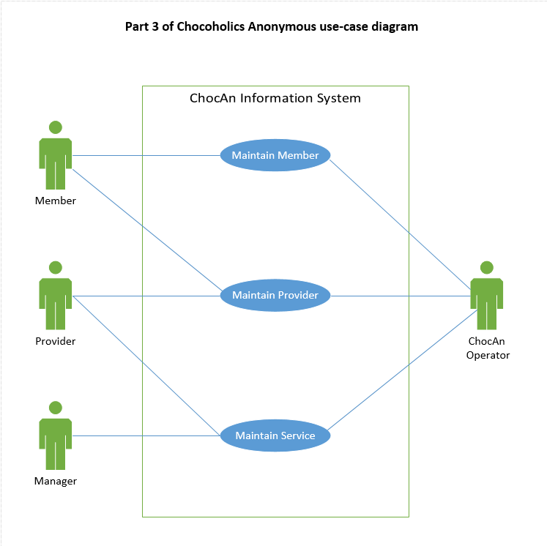

**Description of the Maintain Member use case**

|  |
| --- |
| Brief Description: The Maintain Member use case enables a ChocAn operator to add new members, update the details of existing members and delete members who have resigned. |
| Step-by-Step Description:   1. To add a new member:  When a potential member’s application for membership has been approved and he or she has paid the first month’s fee, his or her details are forwarded to the ChocAn operator.    1. The ChocAn operator selects the option to add a new member, and enters the new member’s details: Member name (max 25 characters) Member street address (max 25 characters) Member city (max 14 characters) Member province (2 letters) Member zip code (7 digits) Member email address (max 50 characters)    2. The system allocates a number for the new member, records the new member’s details, and sets the new member’s status to Active.    3. The system displays the new member’s number and other details. 2. To update an existing member: When a member’s details have changed, the member submits his or her new details to ChocAn.    1. The ChocAn operator finds the existing member details.    2. The ChocAn operator edits the details that must be changed. (The member number can never be changed.)    3. The system updates the member’s details. 3. To delete an existing member: When a member wants to resign, he or she informs ChocAn.    1. The ChocAn operator finds the existing member details.    2. The ChocAn operator selects the option to delete the member.   The system records the member’s resignation and deletes the member’s details at the end of the week, after the accounting procedure has been run. |

**Description of the Maintain Provider use case**

|  |
| --- |
| Brief Description: The Maintain Provider use case enables a ChocAn operator to add new providers, update the details of existing providers and delete providers who have resigned. |
| Step-by-Step Description:   1. To add a new provider:  When a new provider joins ChocAn, his or her details are forwarded to the ChocAn operator.    1. The ChocAn operator selects the option to add a new provider, and enters the new provider’s details: Provider name (max 25 characters) Provider street address (max 25 characters) Provider city (max 14 characters) Provider province (2 letters) Provider zip code (7 digits) Provider email address (max 50 characters)    2. The system allocates a number for the new provider, records the new provider’s details.    3. The system displays the new provider’s provider number and other details.    4. The system sends emails to all members informing them of the new provider. 2. To update an existing provider: When a provider’s details have changed, the provider submits his or her new details to ChocAn.    1. The ChocAn operator finds the existing provider details.    2. The ChocAn operator edits the details that must be changed. (The provider number can never be changed.)    3. The system updates the provider’s details. The system sends emails to all members informing them of the changes. 3. To delete an existing provider: When a provider wants to resign, he or she informs ChocAn.    1. The ChocAn operator finds the existing provider details.    2. The ChocAn operator selects the option to delete the provider.   The system records the provider’s resignation and deletes the provider’s details at the end of the week, after the accounting procedure has been run. The system sends emails to all members informing them of the provider’s resignation. |

**Description of the Maintain Service use case**

|  |
| --- |
| Brief Description: The Maintain Service use case enables a ChocAn operator to add new Service, update the details of existing Service and delete Service that are discontinued. |
| Step-by-Step Description:  The details of new, changed or discontinued services are given to the ChocAn operator by the ChocAn manager.   1. To add a new service:  When a new provider joins ChocAn, his or her details are forwarded to the ChocAn operator.    1. The ChocAn operator selects the option to add a new service, and enters the new services’ details: Service code (max 6 digits) Service name (max 20 characters) Service fee (max $999.99)    2. The system records the new service details.    3. The system displays the new service details.    4. The system sends emails to all providers informing them of the new service. 2. To update an existing service:    1. The ChocAn operator finds the existing service details.    2. The ChocAn operator edits the details that must be changed. (The service number can never be changed.)    3. The system updates the service details. The system sends emails to all providers informing them of the changes. 3. To delete an existing service:    1. The ChocAn operator finds the existing service details.    2. The ChocAn operator selects the option to delete the service.   The system records the discontinuation of the service and deletes its details at the end of the week, after the accounting procedure has been run. The system sends emails to all providers informing them of the discontinuation of the service. |

Part 4 of Chocoholics Anonymous use-case diagram shows the use case in which the ChocAn manager is the primary system actor, namely, to request a report, combined with the use case which is initiated by time, namely, the Accounting Procedure that is run at midnight each Friday.

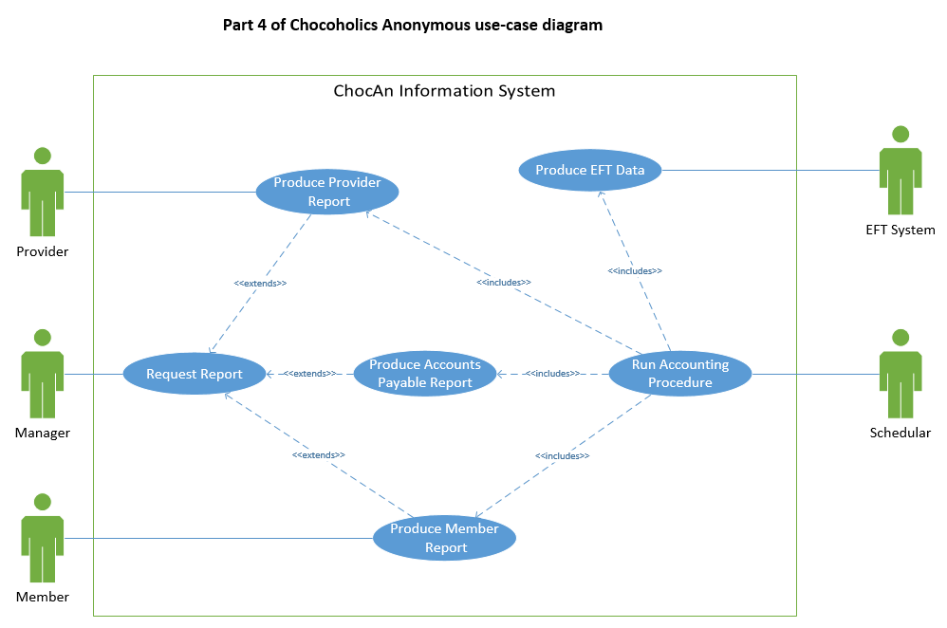

**Description of the Request Report use case**

|  |
| --- |
| Brief Description: The Request Report use case enables the ChocAn manager to request a member report, a provider report or an accounts payable report. |
| Step-by-Step Description:   1. The ChocAn manager selects the report that he or she requires, and enters the end of date of the week he or she requires. 2. Type of report being generated:    1. For a member report, the manager enters the member number. The system generates a member report using the Produce a Member Report use case.    2. For a provider report, the manager enters the provider number. The system generates a provider report using the Produce a Provider Report use case.    3. The system generates an accounts payable report using the Produce an Accounts Payable Report use case. 3. The manager can choose to print the report.   If required, the system prints the report. |

**Description of the Run Accounting Procedure use case**

|  |
| --- |
| Brief Description: The Run Accounting Procedure use case enables the Scheduler to run the accounting procedure so that members, providers and the ChocAn manager receive weekly reports. The use case also enables providers to receive the fees due to them by providing the EFT component with the EFT data. |
| Step-by-Step Description:  This procedure is run every week at midnight on Friday.   1. For each provider, the system generates a report using use case Produce a Provider Report, and sends the report as an email attachment to the provider. 2. For each member, the system generates a report using use case Produce a Member Report, and sends the report as an email attachment to the member. 3. The system generates an accounts payable report for the ChocAn manager using the use case Produce an Accounts Payable Report, and sends the report to the manager as an email attachment. 4. The system produces the EFT data for the EFT component using the use case Produce EFT Data. |

**Description of the Produce Provider Report use case**

|  |
| --- |
| Brief Description: The Produce Provider Report use case enables the system to generate a report of all claims submitted during a specific week by a particular provider. |
| Step-by-Step Description:   1. The system generates the provider report including the following information: Provider name (max 25 characters) Provider number (max 9 digits)  Provider street address (max 25 characters) Provider city (max 14 characters) Provider province (2 letters) Provider zip code (7 digits) 2. For each service provided, the following information, sorted according to claim submission date and time is included: Service date (MM-DD-YYYY) Claim submission date and time (MM-DD-YYYY HH:MM:SS) Member name (max 25 characters) Member number (max 9 digits)  Service name (max 20 characters) Service code (max 6 digits) Total number of consultations with members (3 digits) Service fee (max $999.99) Total fee for week (max $99,999.99) |

**Description of the Produce EFT Data use case**

|  |
| --- |
| Brief Description: The Produce EFT Data use case enables the system to generate a file containing the current week’s EFT data for the EFT component. |
| Step-by-Step Description:  The system writes to a file the following data for each provider who must be paid, for the week: Provider name (max 25 characters) Provider number (max 9 digits) Total fee for week (max $999.99) |

**Description of the Produce Accounts Payable Report use case**

|  |
| --- |
| Brief Description: The Produce Accounts Payable Report use case enables the system to generate a summary report of all services rendered by ChocAn providers and the fees due to them during a specific week. |
| Step-by-Step Description:   1. The system generates the accounts payable report including the following information:    1. For each provider to be paid that week:       1. Provider number (max 9 digits)       2. Provider name (max 25 characters)       3. Number of consultations (max 3 digits)       4. Total fee for week (max $999.99)       5. Total number of providers who provided services       6. Total number of consultations (max 3 digits)       7. Overall total fee (max $999,999.99) |

**Description of the Produce Member Report use case**

|  |
| --- |
| Brief Description: The Produce a Member Report use case enables the system to generate a report of all services rendered to a particular member during a specific week. |
| Step-by-Step Description:   1. The system generates the member report including the following information: Member name (max 25 characters) Member number (max 9 digits) Member street address (max 25 characters) Member city (max 14 characters) Member province (2 letters) Member zip code (7 digits) 2. For each service provided, the following information sorted according to service date is included: Service date (MM-DD-YYYY) Provider name (max 25 characters) Service name (max 20 characters) |